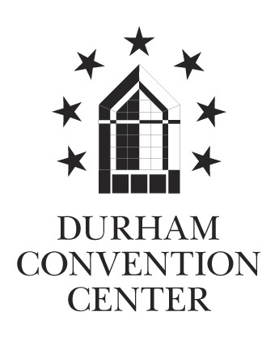

**Durham Convention Center Authority Meeting**

Thursday, September 24, 2015

Durham Convention Center

301 West Morgan Street

11:30 AM (Lunch)

**DCC Authority Members Present**: *Bill Kalkhof, Gerry Link, Lew Myers, Dawn Paffenroth, Alice Sharpe and Darah Whyte*

**DCC Authority Member Absent:** *Richard Ford*

**Spectra Venue Management Present**: *Andrea Gliatta and Jen Noble*

**City and County Representatives Present**: *Drew Cummings, Sharon DeShazo, and Donna Maskill*

1. The meeting was called to order at 12:00 PM by Bill Kalkhof, DCCA chair.
2. A quorum was established for meeting minutes approval. Lew Myers made a motion to approve the August 2015 meeting minutes; seconded by Alice Sharpe, motion carried; minutes approved.
3. **Executive Summary/Major Discussion Items:**

* Spectra Venue Management, the Owners and the DCCA discussed possibilities to resolve the Project Graduation booking conflict. The group wishes to maintain a positive partnership with Project Graduation.
* Drew Cummings, County representative, requested additional data from Spectra Venue Management detailing revenue trends.
* Drew Cummings will follow-up with the City and County Finance Directors on the audit received and report back to the committee via e-mail.

1. **Durham City/County Administration Update:**

**PRIORITY ITEMS:**

* The seven baseboard electric heaters are installed in the corridor. Additional transformers are required for the units. A site visit with the engineer on September 22 was successful. Thermostats needed for completion continues through October 14 and 15.
* Discussions are ongoing regarding coordination of scheduling to retrofit the lobby (which has shared ownership). City of Durham, General Services Project Management Team reviewed the architectural drawings. In addition, drawings were presented to Jen Noble, Spectra Venue Management for review. The City and County staff met with attorneys to review terms of the air-lease as it pertains to shared space and procurement on August 28. Bill Hoy, Shaner was forwarded correspondence regarding additional items for follow-up, including the allocation approach and public bidding requirements.
* Shaner and General Services continue to work together with Comfort Engineers (DCC facility HVAC contractor) on logistics and maintenance for the mechanical equipment. Preparations are underway to issue a Request for Proposal (RFP) for competitive pricing for future maintenance contract work coordinated with and between Shaner, Spectra Venue Management and the Owners.
* Shaner is analyzing the proposal to sub-meter the chiller for electrical usage. Shaner representatives acknowledged receipt of the utilities data and are currently reviewing. Shaner accepted a Memorandum of Understanding for the 50-50 cost split of retro-commissioning the chillers. The contract is being executed. City of Durham staff, Shaner and MBP are working together on this project.
* The Owners presented the DCC audit to the DCCA Finance Committee for review. The incentive payment is due to SVM 30 days after the acceptance of the audit.

1. **Spectra Venue Management (SVM) Update:**

**EVENTS FOR THE MONTH OF AUGUST**

SVM held 28 events with 36 event days booked and 6,145 guests.

**Notable events: Guests**

* NC Arts Council 900
  + - * NC Extension Family & Consumer Science 308
* NuSol Hair Show 1000
* Vistar Tradeshow 389

**OCCUPANCY**: For the month of August is 34%.

**CURRENT FINANCES FOR THE MONTH OF AUGUST**

**Actual Budget Variance**

Gross Revenues $164,393 $90,554 $73,839

Less Event Expenses ($57,742) ($37,419) ($20,323)

Less Indirect Expense ($115,628) ($137,991) $22,363

Net Income (Loss)  **(**$8,977) ($84,856) $75,879

**Year to Date**

**Actual Budget Variance**

Gross Revenues $316,894 $184,819 $132,075

Less Event Expenses ($82,512) ($49,570) ($32,942)

Less Indirect Expense ($235,702) ($279,931) $44,228

Net Income (Loss)  **(**$48,029) ($167,491) $119,462

**Sales Pace: FY2015/16**: Current Sales Bookings as of September 14, 2015.

|  |  |
| --- | --- |
|  |  |
| * + Definite Total | * + $1,259,724.41 |
| * + Tentative Total | * + $229,124.40 |
| * + Proposal Total | * + $260,625.00 |
| * + Grand TOTALS | * + $1,749,473.81 |

**CUSTOMER SURVEY SCORES:** Currently 4.53 out of 5.

* Received feedback from the Triangle Business Journal event on challenges. Corrective action was resolved with staff and SVM is moving forward with the December event.

**STAFFING:**

* Fully staffed.

**SVM PUBLIC RELATIONS:**

* Weekly Rotary meetings and Board meetings
* Social media Facebook/Twitter/Pinterest and website updates
* Triangle Business Journal – Sponsorship for December event

**WEBSITE ACTIVITY:**

* + Visitors: 1,834 New: 82.33%
    - * Demographic: 1,170 Google organic, 343 Direct,

307 Referral, and 14 Social

* + Page views: 4,645
  + Page Visits: 2.53
  + Average duration: 1.39 minutes
* Jen Noble has not received additional feedback on status of DCC lobby retrofit.

1. **Durham Convention Center Authority (DCCA):**

* The committee is requesting updates on the lobby retrofit.
* The committee worked to search alternate facilities and dates to hold Project Graduation 2016. There is concern regarding the economic impact. Alice Sharpe and Bill Kalkhof were instrumental in assisting with finding an adequate space to hold the event. There are three possibilities to date. The Durham Athletic Park is an option. NCCU’s field house is another option and if used, the university preferred caterer is a stipulation. Bill inquired about the possibility of assisting the project with food cost. A final option is the Armory located by the Durham football stadium and owned by the NC National Guard. It is currently going through renovation. The DCC is willing to reduce cost if Project Graduation is agreeable to choose an alternate date. Lew Myers acknowledged the DCC’s commitment in assisting with this project and support of community businesses and organizations.
  + *Please refer to the attached email dated September 25, 2015 from Bill Kalkhof, DCCA chair to James Tabron (Project Graduation).*
* Lew Myers made a motion to approve the maximum amount of the incentive payment for Spectra Venue Management with the understanding that if less is recommended, DCCA will be notified via email to discuss/vote; seconded by Dawn Paffenroth; motion carried, approved by all.

Due to time constraints, the committee will table discussion of the below September agenda items until the October 29 DCCA meeting.

* “In America” marketing proposal
* Proposed Sports Commission update
* Subsequent to the DCCA meeting, Authority members received the attached email from Bill Kalkhof, chair dated October 5, 2015 entitled “Incentive calculation for Spectra-DCC management FY14/15. The Authority voted unanimously to approve the recommended incentive payment of $104,927.

***From:*** *Bill Kalkhof [mailto:bill.kalkhof@gmail.com]****Sent:*** *Monday, October 05, 2015 2:32 PM****Subject:*** *FW: Incentive calculation for Spectra-DCC management FY 14-15*

**Authority Board Members,**

**For your action**

Now that we have finalized the audit, it is time to deal with the incentive for Spectra.

I want to thank Jina for pulling together the information below, and the attached documents, for your review.

**What follows is my review of the documents, and my recommendation for the incentive:**

* The Spectra self-examination provides information related to a number of performance criteria on which its incentive is based.  As a result of Jen’s self-examination, the bottom line of her analysis is that Spectra should receive an incentive of $105,185.
* The City staff analysis of the criteria agrees with Jen’s self-examination with two very minor exceptions:
  + For the criterion “Corporate Citizenry (up to 5%),” Jen recommends $5,264, while the City recommends $5,001.
  + For the criterion “Customer Service (up to 5%), Jen recommends $5,159, while the City recommends $5,163.
* The City recommends an incentive of $104,927.
* The difference is only $258.
* I found the DVCB response not of much use in trying to determine the incentive.

After discussing with Jen the very small difference between the City’s recommendation and Jen’s self-examination, I am recommending that we approve an incentive payment of $104,927.

**Please vote by responding to this email to (1) approve my recommendation, or (2) if you think the incentive should be higher or lower, what is your recommendation.**

FY 14-15 Incentive due = $104,927

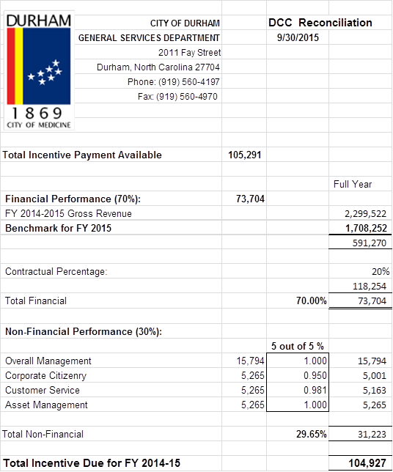

**Subcommittees**

* **FINANCE COMMITTEE**: Lew Myers, and Dawn Paffenroth

City and County staff, the DCCA Finance Committee and members of SVM reviewed and discussed the DCC August 2015 monthly financials. All are pleased with the results. The discussion also included the FY2014/15 audit which was significantly different this fiscal year. The Finance committee had no recommendation on the audit based on the data received. The committee felt that the information was inadequate for the group to make a recommendation. In addition, the committee voiced concerns on timeliness of Spectra Venue Management’s incentive payment.

* At the meeting, the DCCA requested written approval of the FY2014/15 Convention Center audit (with the financial numbers) from the City and County finance directors in order to officially sign off on the audit.  Subsequent to the meeting, the requested information was provided and the DCCA voted to accept the FY2014/15 audit (vote was 6 in favor to accept, with one abstention).  Please refer to the attached email dated October 2, 2015 from Bill Kalkhof, chair to members of the DCC Authority.
* **MARKETING & SALES COMMITTEE***: Darah Whyte, Bill Kalkhof and Gerry Link*

No update to report.

*Attached (below) to the Authority minutes is correspondence related to our decision on the audit*

*Thanks,*

*Bill Kalkhof*

**From:** Bill Kalkhof [<mailto:bill.kalkhof@gmail.com>]   
**Sent:** Friday, October 02, 2015 4:17 PM  
**To:** Alice Sharpe ([asharpe@dconc.gov](mailto:asharpe@dconc.gov)); Darah Whyte; Dawn Paffenroth; Dick Ford ; Drew Cummings ([dcummings@dconc.gov](mailto:dcummings@dconc.gov)); Gerry Link; Jennifer Noble; Jina Propst; Lew Myers; Sharon DeShazo  
**Subject:** FW: convention center audit

**Thank you all for your votes.**

**The final vote was 6 for acceptance, and 1 abstention.**

**Jen, Jina, & Drew:  Is there anything else you need from the Board related to the audit?**

**From:** Bill Kalkhof [<mailto:bill.kalkhof@gmail.com>]   
**Sent:** Wednesday, September 30, 2015 10:19 AM  
**To:** Alice Sharpe ([asharpe@dconc.gov](mailto:asharpe@dconc.gov)); Darah Whyte; Dawn Paffenroth; Dick Ford ; Drew Cummings ([dcummings@dconc.gov](mailto:dcummings@dconc.gov)); Gerry Link; Jennifer Noble; Jina Propst; Lew Myers; Sharon DeShazo  
**Subject:** FW: convention center audit

**Board members,**

**At our meeting last Thursday, we requested written approval of the 2014-15 Convention Center audit (with the financial numbers) from the City and County Finance Directors in order to officially sign off on the audit which is our responsibility.  As noted in Section 5-c-5 of the Interlocal Agreement of our duties and responsibilities, we are charged:  to review, evaluate, and make recommendations to the Governing Boards regarding the annual financial audit report required under the Management Agreement.**

* **In the emails below you will note that the City and County Finance Directors have approved the audit for 2014-15.**
* **Attached above are the June 30, 2015 Balance Sheet and June 30, 2015 Convention Center Fund for June 30, 2015.**

**I believe these emails, and the attachments, meet our request for information which allows us to sign off on the audit for 2014-15.**

**Therefore, we need to take a vote to accept the 2014-15 audit, and send our acceptance to the Governing Bodies.**

**ACTION:  Please ASAP respond to this email, copying Jen, Jina and Drew, with your vote to accept, not accept, or abstain from voting regarding the 2014-15 audit for the Convention Center.**

**I vote to accept the audit.**

**Thank you, Bill Kalkhof**

|  |
| --- |
|  |

*Attached (below) to the Authority minutes is correspondence related to Project Graduation.*

**From:** Bill Kalkhof [<mailto:bill.kalkhof@gmail.com>]   
**Sent:** Friday, September 25, 2015 12:28 PM  
**To:** [james.tabron.iv@gmail.com](mailto:james.tabron.iv@gmail.com)  
**Cc:** Jennifer Noble  
**Subject:** FW: Project Graduation

JT,

Enjoyed our phone conversation earlier today.

At our Authority Board meeting on September 24, I provided an update of our joint efforts to determine if there was another venue in Durham that could host Project Graduation in 2016.  At our meeting, I also was informed that Project Graduation has asked that June 13th be blocked off for your 2016 celebration if it is held at the Convention Center.  Thanks for having your colleagues reserve that date.

Here is what the Convention Center Authority’s Board would like to suggest to you and your colleagues:

* If your celebration is held at the Convention Center on June 13, 2016, as a special consideration to your organization, we will discount your room rental fee to $5,000 for your 2016 celebration.
* Should you decide to enter into negotiations to move your event to another location (for example the Athletic Center at NCCU, the DAP, the Armory by Durham Stadium), please let us know if we can be of any assistance in that effort.
* Given the challenge (as outlined in your previous email to me) Project Graduation faces in providing the Convention Center management team with an exact date for the celebration, beginning with your 2017 celebration, the Convention Center will “grey out” the dates of June 10 – 11 on its schedule.  Should another client contact the Convention Center seeking to hold an event on the “grey out” days, the Convention Center management team will contact Project Graduation to confirm the “grey days” before entering into contracts with another client.  In order to confirm the “grey days,” assuming the Convention Center has a client who would like the same days, the Convention Center will require Project Graduation to sign a contract.
* It is very important that we keep the lines of communication open.  Therefore, we would benefit from knowing who your designated contact person is as we look to the future.

I have enjoyed working with, and getting to know, you --- even if it has only been by email and phone.  Look forward to meeting you in person soon.  Give my best to your dad.

Thanks.

Bill Kalkhof

|  |
| --- |
|  |