**About the 2025 Reappraisal**

**Reappraisal** is the process of taking a January 1, 2025 **market value** “snapshot” of all Durham County real property. Real property includes all the land itself; buildings, structures, and improvements on the property; and all rights and privileges belonging to the property. There are four general classifications of real property:

* Residential
* Agriculture
* Commercial/Industrial
* Exempt

The market value, also referred to as the appraised value becomes the taxable value on which tax bills are calculated unless the property qualifies for an exemption, exclusion, or deferment. The appraised value will not change until the next scheduled reappraisal (2029) unless the property owner makes changes to the property. Examples of reasons for changing the value may include new construction or zoning change. Appraised values change mostly due to physical property changes.

When the appraised value changes, state law requires the assessor to appraise the property as if it existed in its current state on the reappraisal date, January 1, 2025.

For example, if a

house is built in

2027 on a lot that

was vacant prior

to 2025, the new

house and lot appraised value will

be determined using January 1, 2025, market values.

**Why We Reappraise**



North Carolina state law **requires** all counties

to reappraise real property every eight years.

Durham County’s last reappraisal took effect on

January 1, 2019, our next reappraisal will become

effective January 1, 2025.

Over time, property values in the county change at different rates. For example, there may be a lot of growth in one area of the county causing market values to increase faster than in other parts of the county.

Since property taxes are based on property values, unequal changes in values means some property owners pay more than their share, while others pay less. The purpose of the reappraisal is to reset all property values back to market value, so that the property tax burden is spread fairly across all taxpayers.

**When will you be notified?**

Written notice of the **2025 Appraised Value** will be mailed to all property owners in February 2025. The tax office will issue a press release alerting property owners of the exact mailing date.

**Will your tax bill change?**

Not necessarily. The annual tax bill for each property is calculated by multiplying the tax value by the tax rate, which is determined each year by each taxing jurisdiction—the county commissioners, city council, fire districts, etc. Some tax bills will go up, some will go down, and some will stay about the same.

**How Reappraisal works**

To accomplish the task of valuing all parcels within the county as of the January 1 reappraisal date, the methodology of mass appraisal must be utilized.

We examine every recorded sale of property in the county, review building cost data, and gather income/expense information from income-producing properties. These data sources assist us in developing schedules, standards, rules, tables and other factors used to apply the correct appraised value to over 125,000 individual properties, even though they may be of different types and locations.

Mass appraisal methods and processes are like the techniques used by single-property appraisers, but they follow a different set of appraisal industry standards, since they are designed to predict market values for groups of properties rather

Durham County

appraisal staff are

certified by the

North Carolina

Department of

Revenue to

perform property

tax appraisals.

than an individual property.



For the 2025 reappraisal, every property

in Durham County will be reviewed

through a combination of computer-based

and field reviews to ensure property

characteristics are reflected accurately in

the county tax records.

**What “Market Value” means**

North Carolina General Statute 105-283 defines market value as follows:

*“the price estimated in terms of money at which the property would change hands between a willing and financially able buyer and a willing seller, neither being under any compulsion to buy or to sell and both having reasonable knowledge of all the uses to which the property is adapted and for which it is capable of being used.”*

Another way to say it is that market transactions are those that happen at “arm’s length,” or situations where buyers and sellers are reasonably informed, acting in their own best interests, and under no pressure to buy or sell.

**What Market Value is not**

There are many types of transactions that do not generally meet the market value standard. Examples of transactions that must be carefully analyzed to determine if they can be qualified as a market sale include:

* Sales that occur as the result of a foreclosure
* Auction or Estate sales
* Sales between related parties, and
* Sales involving exempt institutions

Similarly, there are other meanings of the term “value” that are usually not the same as market value. Insured value, salvage value, present use value, book value, or actual construction cost must be compared to the market value definition to determine whether they are indications of market value.

**Is Market Value the Same as Sale Price?**

Individual transactions, even if they are “arm’s length,” do not necessarily occur exactly at the expected market rate. Since every combination of buyer, seller, and property is unique, there will normally be factors that cause the price for a particular transaction to be higher or lower than what the market would predict.

Put another way, some deals are better or worse than others. Our appraisers examine the market and compare an individual transaction to similar transactions. Regardless of the terms of a single sale, lease, or building cost, every property must be evaluated in terms of what is reasonable and typical in the market for the property type and location.

**How your tax value is determined**

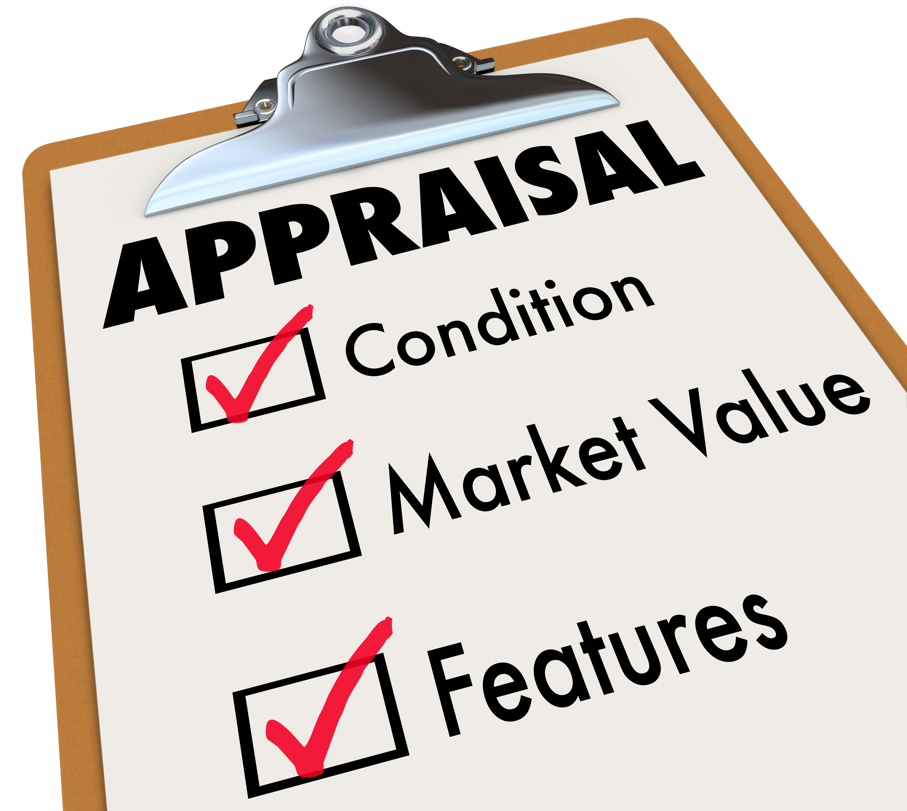

**Market value** is not determined by the tax office;

rather, it is determined by the actual activity in the

local market. Appraisers examine and analyze

market activity to develop formulas for establishing

the values of property groups.

For example, although not all properties will sell, or rent, or be built at the same time, information from market sales can be used to establish typical market rates. The rates can then be applied to all properties to ensure fair and equitable values are assigned to individual properties.



**How to Appeal Your**

**Appraised Value**

If you disagree with the appraised value of your property as indicated on the Notice of Value Change, you have the right to appeal.

**What is your Estimate of Value?**

**\*\*Owner’s Opinion of Value should be a reasonable estimate of what the property was worth on January 1, 2025.**

1. Visit [www.dconc.gov/taxhelp](http://www.dconc.gov/taxhelp)
2. Click the "**Real Property Record Search**."
3. Type in your **REID**/parcel number, which is printed on the notice you received and “click” **REID**, then press **ENTER**.
4. Now you are viewing your property record card. The tab labeled "**$ Sales**" across the menu bar will allow you to review the sales of other properties in your market area. This is intended to help you evaluate the tax appraisal of your property.

1. After your review, if you believe that the appraised value is erroneous, you can begin the **APPEAL** process by returning to the **Main Menu** to select the **Tax Help** option located at the bottom of the side bar.
2. select the GREEN “Submit to Review & Compare” button.
3. Once onto the next screen, please select “Step 3: APPEAL” and follow the prompts in filling out the APPEAL form.

**Our Promise to You**

The Tax Administrator’s Office follows established industry standards for mass appraisal. We are fortunate to have experienced staff with vast years of appraisal experience in both the public and private sector. Their experience spans decades in Durham County, other North Carolina Counties, and States across the US. They are greatly knowledgeable with the methodology of conducting a reappraisal.

Even so, reappraisals are challenging. Undertaking the task of valuing tens of thousands of properties as of the January 1 reappraisal date, is a highly visible and politically sensitive undertaking.

Our staff is committed to assist property owners to:

* ensure fairness
* maintain equity
* respectfully conduct appeals
* remain transparent throughout the process



***Reappraisal Goal –*** *to appraise all Durham County Properties as of January 1, 2025, in a way that is fair and equitable to all property owners.*