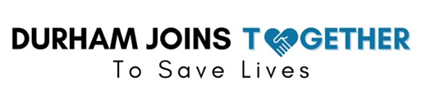
Mental Health and Substance Use Disorder Treatment Committee
Tuesday, August 12, 2025
3:00 PM - 4:30 PM
*Zoom and Phone Access Only
Welcome
Introduction/Guests

Minutes
Review and Approval of Minutes: June 10, 2025

New Business

Presentations/ Discussions
- “You Have the Power to Save Lives” - Dr. Wanda Boone, CEO Together for Resilient Youth
- Recovery Innovations and DRRC Updates - Joy Brunson-Nsubuga, COO, Recovery Innovations
Program Updates
- MOUD/SUD Treatment Providers
- Durham County Agency and Department Updates
- Housing and Provider Subcommittees
- Harm Reduction Providers
- Others

Ongoing Commitment
- Identify strategies that reduce stigma and increase access to SUD treatment, harm reduction and diversion programs, particularly among BIPOC and other marginalized populations.
- Discuss ways to increase access to Peer Support for SUD and provide a support network for Peer Support Specialists.
- Develop ideas and actions to address housing barriers for people with SUD and justice-involved populations.
- Identify additional stakeholders to participate on the committee.

*Next Mental Health and SUD Treatment Committee Virtual Meeting:
Tuesday, September 9, 2025, from 3:00 PM - 4:30 PM

