# Durham Familiar Faces Initiative Quarterly Meeting

Members Present:

Wendy Jacobs

Ryan Smith

Marc Strange

Kimberly Monroe

Shanta Addison

Helen Tripp

Russell Pierce

Beth Steenberg

Sally Wilson

Michele Easter

Eric Johnson

Roshanna Parker

Colin Davis

Julia Gamble

Nicole Schramm-Sapyta

1. Update on Point in Time/Annual Homelessness Report and Carver Creek Campus-Russ

See the detailed report from the Point in Time (PIT) count at this link:

[PowerPoint Presentation (durhamnc.gov)](https://www.durhamnc.gov/DocumentCenter/View/56107/2024_PITHIC_Report)

Homelessness has generally increased in Durham, including the number of families, people with SUD and/or SMI, and people who are chronically homeless. Overall, homelessness is up 300% in the past 5 years. The numbers in the report should be considered reflective of general trends, and likely undercount the total numbers of people in need of housing. A new committee has been formed by the city, county, and school system to do a detailed assessment of supply and demand for housing. IT is expected to convene in August.

Carver Creek:

At the facility, they have increased security, provided internet access to all residents, installed new laundry facilities, and replaced locks on all doors. An internal Housing for New Hope group will begin to develop a long-term master plan starting soon.

1. Update from FFI Supportive Services Committee-Shanta

The committee are working out logistics to have Durham Community Food Pantry deliver food boxes to the facilities.

They are still working to identify partners to help teach residents about digital literacy.

Financial Literacy classes began this week, with PNC bank. About 4 residents attended. There will be 6 sessions total.

Community Paramedics, led by Helen Tripp, will begin providing services at Andover apartments once per month and Williams Square apartments once per month. Residents of all facilities (Andover, Williams, and Carver Creek) will be invited to attend any of the visits. Paramedics hope to build relationships with residents to be able to observe changes in health, and also provide vital and EKG checks, medication checks, education, referrals, and general support. The first visits will be to Andover on July 23 and Williams Square on July 31. Paramedics will plan to stay for about 2 hours, but will stay as long as there are patients to be seen.

The supportive services group also asked for additional representation and a re-check on the intersection of this subcommittee with the full group. Kimberly Monroe indicated she would like to start attending, but needs a different standing meeting time. There are also ongoing conversations with the Duke School of Nursing and the Impact Clinic, so those should be included as well.

1. Update from FFI Data Committee- Anise and Beth

Please see attached report (below) from Beth with detailed updates and diagram.

1. Update from FFI Pilot- Ryan and Roshanna- 15 minutes

This group has had recent success in engaging the Department of Social Services and Adult Protective Services as collaborators. They are also engaging with a separate group that meets weekly to help support about 16 people with high need in our area. This group partners with Duke Hospital and Duke Regional. They described one specific Familiar Neighbor with very complex needs, and the group brainstormed supports for this person.

1. Report from Ryan and Marc on NACo FFI Peer Justice Learning Network site visit to Orange County, California

The trip to Orange Co, CA, was very enlightening. Big take-aways were:

They have an excellent data platform, System of Care Data Integration System (SOCDIS)

They have a specific office of care coordination

To replicate some of their successes here, we need support at very high levels, which we are beginning to get.

They have a Multidisciplinary Team to focus on specific neighbors that meets two times per month.

Other topics discussed at the end of the meeting:

Considering more immediate solutions for our neighbors in greatest need, such as “pallet communities.” It was mentioned that there are NC laws limiting the length of time a pallet shed can be used as a home, but that we might be able to use “tiny houses” instead to meet this need.

The next meeting will be in-person for all who can attend. Roshanna offered that JSD would host and provide coffee and bagels. The date will be October 11, 2024.

**Potential Pathways**

*Familiar Faces Initiative Data Sub-group*

*7/12/2024*

The Familiar Initiative Data Sub-Group has worked along several lines to assist the overall Familiar Faces Strategic Initiative. In those efforts, we have:

* Gathered a basic descriptive picture of familiar faces across Justice Services, Community Safety, Durham Police, and EMS. We are working to add Duke ED and Durham Regional to that picture.
* Pursued a research project led by Michele Easter that would connect HEART data to Duke health system data. That research project aims to better understand the intersection between familiar faces and the local healthcare system. The project is currently in the IRB process at Duke.
* Pursued and received access for DCSD to access MedLink, Duke health’s patient records system.
* Engaged in case study work and conversations with jurisdictions who have successfully integrated data systems.

At this point, there are many different pathways that the data sub-group could take. Five such pathways are shown in the visual below. The sub-group is unsure of what would be most useful to the larger familiar neighbors initiative. As such, we would like some direction on what, if any, of the pathways below should be pursued.

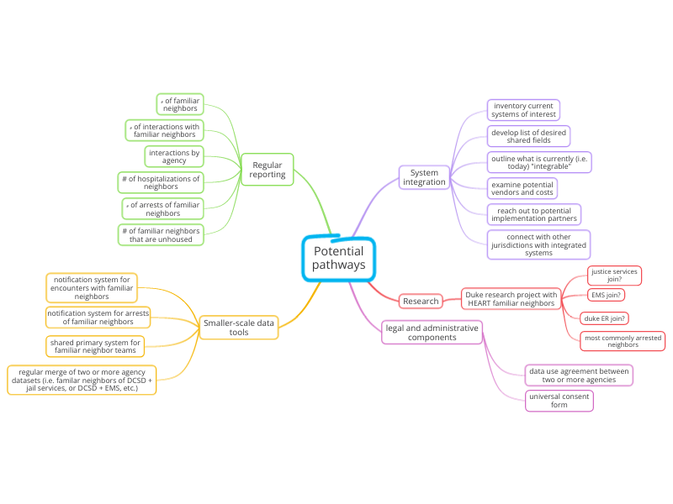

Below, please find some prompts for discussion.

* Which of the pathways or activities in the visual felt most urgent and/or necessary?
* Are there pathways that are missing? Or particular activities?
* Are there pathways that seem irrelevant or untimely?
* Are there specific data points that we would, in an ideal world, like to have at our fingertips?
* Among the pathways that feel most relevant to our work, is there a top priority?