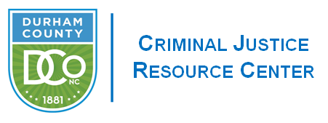

**JUVENILE CRIME PREVENTION COUNCIL April 28, 2021 Meeting Minutes**

**Members Present:** Nisha Williams, Angela Nunn, DeWarren Langley, Frederick Kearns, Jennifer Meade, Leah Selvy, Tasha Jones Butts, Shannon Teamer, Kevin McIver, Judge Evans, Solina Richards, Andre Hinton, Drew Cummings, Chenelle McInnis, Kelvin Allen, Lindsey Spain

**Staff:** Gudrun Parmer, Kelley Waggy, Eddie Crews

**Welcome & Introductions**

Vice Chair Angela Nunn called the meeting to order and welcomed the full body.

**Review of March Minutes**

Vice Chair Angela Nunn presented the March minutes and asked the Board to briefly review them. Drew Cummings moved to accept the March minutes, Kelvin Allen seconded the motion, the board voted unanimously to approve. Motion carried.

**El Futuro Reallocation of Funds**

Vice Chair Angela Nunn shared that El Futuro submitted a request for additional funds in the amount of 5,754.39 to purchase 3 laptops. El Futuro will be providing the required 30% Match. These funds will be pulled from the funds previously returned by BUILD and Youth Mediation Circles. DeWarren Langley Made a motion to approve this request, Kevin McIver seconded the motion. The Vote was held via Roll Call on Zoom and was unanimous for the approval of additional funding.

**Funding for FY 22/23**

Treasurer, Kelvin Allen, briefly reviewed the JCPC funding Principles and presented the Funding Committee’s recommendation to the whole board. The Funding Grid was displayed for viewing by the JCPC Board. The Board was able to view and compare the averaged funding recommendations and the Funding Committee’s recommendations.

Kelvin Allen Opened the floor for to discussion per the Durham County Bylaws.

DeWarren Langley made a motion to approve the funding recommendation of the Funding Committee as presented.

Drew Cummings Seconded this motion.

The vote was held via Roll Call and was unanimous in the approval of the presented funding for F.Y.21-22/23.

Angela Nunn shared that the Motion Carried.

Vice Chair Angela Nunn shared her thanks for the hard work of all involved in the funding process.

**Announcements**

Angela Nunn congratulated Member Andre Hinton on the birth of his son.

DeWarren Langley shared that the deadline for The Durham Youth Works Program was extended to May 2, 2021. DeWarren asked that members share this information within their networks. DeWarren highlighted the work in Durham to expunge the convictions for the youth in Durham that occurred prior to Raise the Age, as well as, remind the board of the Community Police Relations Forum held via ZOOM occurring directly after this meeting at 6p.m.

The Meeting was Adjourned at 4:37p.m.