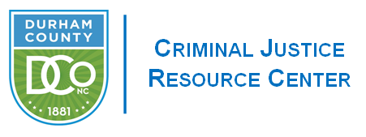

**JUVENILE CRIME PREVENTION COUNCIL April 27, 2022 Meeting Minutes**

**Members Present:** Nisha Williams, Angela Nunn, DeWarren Langley, Ahmed Ali, Jennifer Meade, Leah Selvy, Tamala McDowell, Kevin McIver, , Drew Cummings, Bonita Graham, Frederick Kearns, Joseph Jackson, John Morris

**Staff:** Gudrun Parmer, Kelley Waggy, Eddie Crews

**Welcome & Introductions**

Chair Nisha Williams called the meeting to order and welcomed the full body.

**Review of March Minutes**

Chair Nisha Williams presented the March minutes and asked the Board to briefly review them. Leah Selvy moved to accept the March minutes, Jennifer Meade seconded the motion, the board voted unanimously to approve. Motion carried

**Funding for FY 2023**

Chair Nisha Williams gave a brief overview of the funding process for the two new members that were in attendance and were not on the board prior to this meeting. Nisha also shared with the Board that El Futuro did not apply for funding and as such their $25,000 would be released back to the pot. Drew and Nisha opened the floor for a detailed discussion as to how the board would like to move forward with the reallocation of these funds. The Board agreed unanimously to hold that money and allocating it in the new fiscal year.

Interim Treasurer, Drew Cummings, briefly reviewed the JCPC funding Principles and presented the Funding Committee’s recommendation to the whole board. The Funding Grid was displayed for viewing by the JCPC Board. The Board was able to view and compare the averaged funding recommendations and the Funding Committee’s recommendations.

Drew Cummings Opened the floor for to discussion per the Durham County Bylaws.

Nisha Williams made a motion to approve the funding recommendation for EPIC as presented.

Angela Nunn Seconded this motion.

The vote was held via Roll Call in the ZOOM Chat and was unanimous in the approval of the presented funding for F.Y.2023.

Drew Cummings shared that the Motion Carried.

Angela Nunn made a motion to approve FY 2023 funding recommendation of the Funding Committee as presented.

Bonita Graham Seconded this motion.

The vote was held via Roll Call in the ZOOM Chat and was unanimous in the approval of the presented funding for F.Y.2023.

Drew Cummings shared that the Motion Carried.

Chair Nisha Williams shared her thanks for the hard work of all involved in the funding process.

**Announcement**

Sabrina Shared the following information: 4/28/2022 5:30-7:00pm “Depression and addictive substances in teens”

5/26/2022 5:30-7:00pm “Creating Connections”

The Meeting was Adjourned at 5:20p.m.