

**JUVENILE CRIME PREVENTION COUNCIL February 22, 2023 Meeting Minutes**

**Members Present:** DeWarren Langley, Ahmed Ali, Kevin McIver, John Morris, Joseph Jackson, Alex Hurdle, Jim Stuit, Seth Kandl, Leah Selvy,Laylon Williams, Angela Nunn, Tamala McDowell

**Programs Present:** Quillie Coath, Yasmin Boone, Mariah Macon, Lucretia Williams, Raquel Dominguez, Stephanie Garcia, Arkeem Brooks, Cynia Black, Gwen Johnson, Monica Daye, Lety Bridges

**Guest:** Kayla Merkel, Adreanna Williams

**Staff:** Gudrun Parmer, Kelley Waggy, Eddie Crews, Jim Stuit, Katie Conyers, Roshanna Parker

**Welcome & Introductions**

Chair DeWarren Langley called the meeting to order at 4:08pm and welcomed the full body. The Full Body introduced themselves.

**January 25, 2023, Minutes**

DeWarren Langley presented the January minutes to the board. Angela moved to accept the December minutes with the discussed spelling correction. Seth seconded. The board voted unanimously.

**Presentation of Resolutions**

* **Judge Pat Evans-** DeWarren presented the formal Resolution honoring Judge Evans (attached) and the board shared their individual experiences and Gratitude for Judge Evans many years of service to Durham County and the Youth of Durham County. Judge Evans shared her appreciation and enduring dedication to the Juvenile Crime Prevention Council.
* **Drew Cummings**- DeWarren presented the formal Resolution honoring Drew Cummings (attached) and the board shared their individual experiences and Gratitude for the many years of service to Durham County and the Youth of Durham County. Drew Cummings shared his appreciation for recognition to the Juvenile Crime Prevention Council.

**Reports**

* **Area Consultant**- Eddie shared that the RFP training was held earlier in the day and there was a nice turnout, it was also shared that once the applications are submitted, they will be distributed to the board for review ahead of the JCPC Funding presentations.
* **Chief Juvenile Court Counselor**-Tamala shared the in January there were 79 complaints received, 12 of those complaints were approved, 4 were diverted and there were 6 Detention admissions.
* **Chair**- DeWarren shared that there 19 programs present for the JCPC RFP Applicant Training held prior to today’s meeting. It was shared that the council had been emailed information about the Durham Youth Works program that is currently accepting applications. They have capacity for 500 young people this summer, so please share that with your networks is wide and broad as possible, so we can assure as many young people get career, exposure, and development opportunities this summer as possible. DeWarren shared that there will be some other opportunities that he will be sharing as well regarding the North Carolina Juvenile Services Association Conference.

**New Business**

* **Monitoring Committee Reports** 
  + Proud: Angela shared that all services provided were reviewed and there were no issues found. Proud is expected to serve the number of Youth proposed and the team recommends continuation of funding.
  + JLC: John shared that Bull city has been on pause since October with the intention of restarting in February. JLC is currently unable to get back into schools and are currently only serving 2 youth. The team requested and recommended follow up with Eddie.
  + Conflict Resolution Center: Ahmed shared that after reviewing the program there were concerns in regard to low numbers. The team requested Eddie review and update with recommendations.
  + Project BUILD: Leah shared that this was her second-year monitoring BUILD and it was a pleasure for her Team and herself. There were no issues and the teams’ recommendations was for continuation of funding.
  + EPIC: Kevin shared that everything was moving in the right direction and the only issue they found was the programs relationship with the court counselors and he recommended less rotation in an effort to form better relationships.
  + Teen Court & Restitution: DeWarren shared that upon review this program was not receiving sufficient referrals from the court. While the program plans on meeting their service numbers there was some concern from the teams in regards to their ability to do so. The recommendation here is to fortify relationships with referral sources.
  + Parenting of Adolescents: DeWarren shared that POA was on schedule to meet their projected numbers. The Team had no concerns regarding this program.

DeWarren shared that it was clear upon hearing the reports that further efforts needed to be made both by the Council and the Programs to form better relationships with referral sources. There was a proposal for future resource fairs in an effort to eliminate this issue in the future.

* **FY 2023-2024 Request for proposal applicant schedule**

The board was asked to block their calendars for April 4, 2023, and April 5, 2023 from 1-4pm for Applicant Presentations. Once all applications are received the board will receive and update to these dates and time frames.

* **Supplemental questions for applicants**

**Announcements**

DeWarren asked that the Council look for his announcements via email.

**Adjourn**

The meeting was adjourned at 5:35pm

**Next Meeting**

**March 22, 2023**

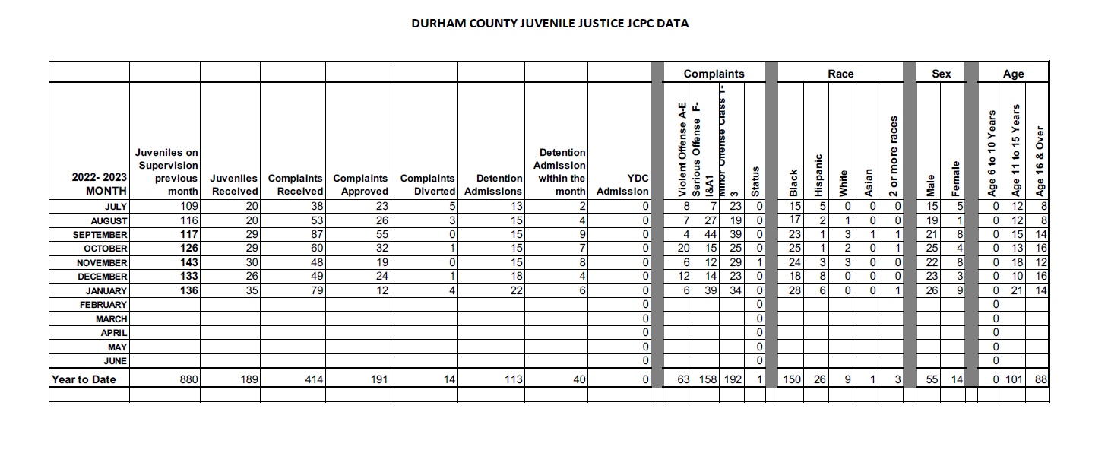

[**https://acrobat.adobe.com/link/review?uri=urn:aaid:scds:US:055c20fb-db0e-31b0-b90c-0980ea17eb74**](https://acrobat.adobe.com/link/review?uri=urn:aaid:scds:US:055c20fb-db0e-31b0-b90c-0980ea17eb74)

[**https://acrobat.adobe.com/link/review?uri=urn:aaid:scds:US:ebe79c17-0a3f-3937-ba18-501267689b1b**](https://acrobat.adobe.com/link/review?uri=urn:aaid:scds:US:ebe79c17-0a3f-3937-ba18-501267689b1b)