

**Durham Convention Center Authority Meeting**

Thursday, June 27, 2019

Durham Convention Center

301 West Morgan Street

**DCC Authority Members** Present: *Richard Ford,* *Jason Friday, Bill Kalkhof, Lew Myers, Alice Sharpe, Craig Spitzer, and Darah Whyte.* **Spectra Venue Management (SVM)** Present: *Rebecca Bolton and Andrea Gliatta*

**City and County Representatives** Present: *David Boyd, Drew Cummings, Sharon DeShazo, Carlos McCall, Trish Creta, Fallon Thompson, and Jina Propst*

*Fallon K. Thompson, General Services was introduced as Sharon DeShazo’s upcoming replacement as Sharon moves on from the organization via retirement with the City of Durham.*

1. A quorum was established for meeting minute’s approval. Lew Meyers made a motion to approve April 25, 2019 meeting minutes; seconded by Richard Ford, motion carried; minutes approved.
2. **REBRANDING:**

Rebecca has funds for re-branding included in FY2019 operations.

1. **PUBLIC ART:**

Stacey Poston, General Service’s division head for the Public Art initiative provided insight on upcoming projects and its need for funding. One of the City’s goals is to leverage public dollars with private dollars. One opportunity voiced during the discussion is the North Carolina Museum of Art wishes to expand beyond its museum boundaries. A proposal is to have the North Carolina Museum of Art provide $15,000 in funding for two permanent murals installed on each of the loading dock doors using local artists (one artist from Durham and the other from Greensboro) to replicate Diego Rivera and Frida Kahlo mural images. The two artists reproduced on the murals are known public artists from the early 1930s. There is a $14,000 gap for financing this project. Rebecca Bolton offered to reach out to Google Fiber for possible funding. Stacy added that fundraising efforts are taking place. Lew made a motion for the DCC to provide funding to finance the murals through operational funds while pursuing other funding options to make the Public Art project complete. Alice Sharpe seconded; voted and approved by all. Stacey is currently pursuing private funding sources and is appreciative of any additional funding provided. Lighting is also a part of this project for consideration, though secondary.

1. **DEDICATION PLAQUE EVENT**

The re-dedication ceremony held on June 26 was a tremendous success and well attended. The cost was absorbed by the DCC. The purpose of the event recognized the original stakeholders and achievements of the DCC operations.

1. **DURHAM City/County Administration Update:**

**Capital Projects: FY2019: Budget:**

* + Fireproofing

PFC $66,000  
Loading Dock - Shared $21,000

There was a June 24 kick-off meeting with Spectrum, Shaner and City of Durham General Services Department and the contractor on-site to review and coordinate the schedule and logistics. The construction is underway June 24 – July 4. The contract total cost is $85,441.00. Shaner will cost-share with the Owners on this project.

* Kitchen Equipment Replacements (hot boxes) $4,421.00
* Wireless Upgrade – Switch upgrade,

foundation for access points next fiscal year $9,975.00

* + Kitchen Equipment Improvements (equipment and installation) $53,000

Rebecca Bolton, Spectra is leading this project with support from City Project Management Division. The floorplans with the layout are received. The inspector was consulted, and the electrical quote received. Spectra reviewed a phasing plan. A corporate kitchen consultant is providing detail with quotes for reduced pricing on equipment from Spectra corporate.

* + Tables $9,129.96

Trish Creta, City of Durham Project Manager, has been working to ensure contracts are underway for the above projects.

**Capital Project FY2020 Budget:**

* + Exterior Signage (Carry over to FY2020) $55,000

Proposals received for Exterior Signage CD’s

* + Small Kitchen Equipment Replacements $4,000
    - Hot Boxes
  + Wireless/Technology Upgrades (carry-over $40,000 to FY2020) $40,000
  + Air wall Damage (carry over to FY2020) $20,000
* Air Wall Damage (funds needed for deficit) $24,000
* Rooftop Air Handler (2) – lobby area $40,000
* Pre-function Furniture Replacement $29,274

Interior Designer for furniture replacement

* Bathroom Renovation (carry over FY2020) $50,000

Interior Designer for bathroom renovation

* Interior Designer $30,000
* Security Cameras $40,000
* Small Wares $30,000
* Walk-in Freezer $28,000
* Kitchen Ovens $24,000
* Phase Two Kitchen $50,000

All work above, is in progress for initiation and contracting by mid-July and no later than the first quarter of FY2020.

1. **MANAGEMENT AGREEMENT EXTENSION**

The City Council and County Commission have approved the ten-year Management Extension contract with Spectra.

1. **SPECTRA VENUE MANAGEMENT (SVM) UPDATE:**

**Events for the month of MAY 2019**

SVM held 42 events with 7,265 guests.

**Notable events: DCC Revenue Guests**

* + - * Engaging Local Gov. Leaders (2-day convention) $42,510 550
      * Duke PhD Hooding (special event) $87,460 1650
      * Duke Computer Science Graduation (special event) $23,982 1110
      * BB&T Town Hall $19,207 350
      * NCCU (2 separate banquets) $37,073 900

**FINANCIAL OVERVIEW FOR MAY 2019**

**Actual Budget Variance**

Gross Revenues $364,762 $290,782 $73,980

Less Event Expenses ($134,543) ($115,712) ($18,831)

Less Indirect Expense ($148,702) ($149,765) $1,063___

Net Income (Loss) $81,517 $25,305 $56,212

**FISCAL YEAR 2019 YTD AS OF MAY 2019**

**Actual Budget Variance**

Gross Revenues $2,802,216 $2,433,126 $369,091

Less Event Expenses ($1,091,012) ($953,472) ($137,540)

Less Indirect Expense ($1,644,028) ($1,717,110) $73,082

Net Income (Loss) $67,176 ($237,457) $304,632

**2020 Annual Budget Revenue Projection Status**

|  |  |  |
| --- | --- | --- |
| Total Projection | Budgeted Total Gross Income | % of the Gross Year-end Budget |
| $1,717,200 | $2,708,132 | 63% |

**Sales Pace for FY2019 as of June 21, 2019**

|  |  |
| --- | --- |
| Definite/Actual Total | $         3,024,955 |
| Firm Total | $         0 |
| Total Projection | $         3,024,955 |

**Sales Pace for FY2020 as of June 21, 2019**

|  |  |
| --- | --- |
| Definite/Actual Total | $         1,050,484 |
| Firm Total | $         251,188 |
| Proposal Total | $         415,528 |
| Total Projection | $         1,717,200 |

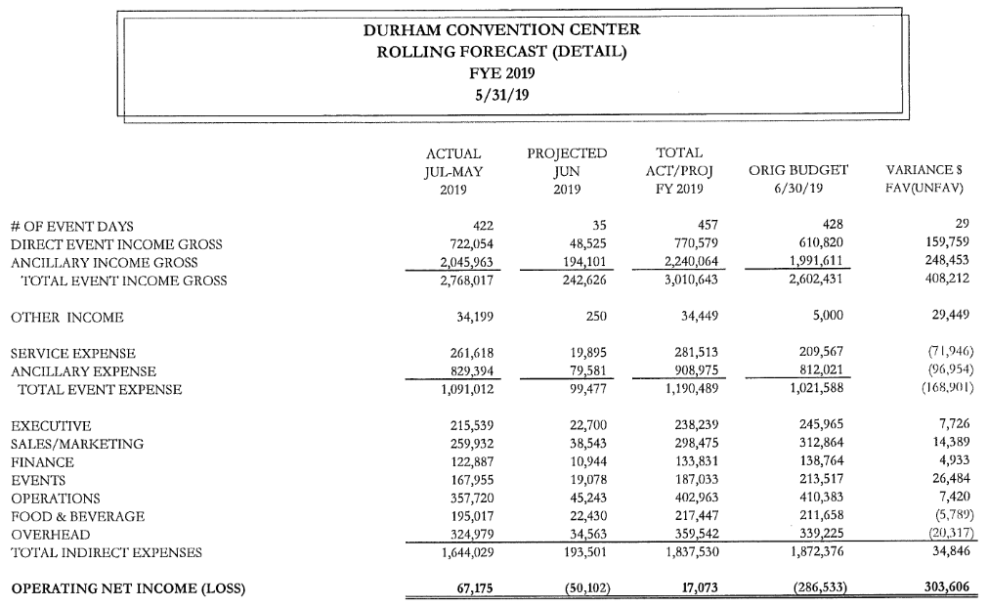

**Sales Pace for FY2019 as of April 23, 2019**

|  |  |
| --- | --- |
| Definite/Actual Total | $2,653,011 |
| Firm Total | $15,577 |
| Proposal Total | $6,901 |
| TOTAL PROJECTION | $2,675,489 |

**CUSTOMER SURVEY SCORES:** 4.68 out of 5

**WEBSITE ACTIVITY:** February 16th – March 16th

**2018 2019**

* + Sessions (Visitors): 1,391 1,896
    - * New Sessions: 86.7% 87.6%
      * Page Views 3,193 4,173
  + Page/Session: 2.30 2.20
  + Average Session duration: 1.00 minutes 1.22 minutes
  + Organic Search 560 754
  + Direct Search 535 711
  + Referral Search 70 186

Rebecca Bolton and Jina Propst continue to collaborate on improvements for the Plaza space to make it more inviting.

Lew Meyers announced that Rebecca Bolton was recently officially elected to serve on the Downtown Durham Inc. (DDI) board.

1. **DCCA**

Jason Friday is a City appointee, and his term ends July 31, 2019. His position on the DCCA will be advertised for reappointment. Jason will not be returning next meeting. He expressed his sincere appreciation for his tenure on the Authority. His contribution as a member is well received by the other members of the Authority.

Lew Meyers is the Mayor’s appointee and has been reappointed for three years ending July 31, 2022.

Bill Kalkhof made a salutation to honor the successful Spectra General Managers for the strides they’ve made in the success of the Durham Convention Center – Jen Noble, past General Manager and Rebecca Bolton, current General Manager.

Bill Kalkhof noted that this is his final meeting as chair of the DCC Authority, a position he’s held since August 2015. He thanked the Authority members for their support over the past four years, and the outstanding work of the Spectra Management team relating to the financial and programming success of the Convention Center. Bill applauded to great partnership among the Authority, The City and County, and Spectra Management, giving special recognition to the leadership of Rebecca Bolton.

1. **SUBCOMMITTEES**

* **FINANCE COMMITTEE**: *Lew Myers, Richard Ford, and Jason Friday*

City and County staff, the DCCA Finance Committee and members of Spectra Venue Management discussed May 2019 financial results. Revenues for the month are above budget at $364,762, showing a favorable variance of $79,980. May shows a monthly profit of $81,517. Indirect expenses are below budget by $73,082 for the fiscal year. The DCC anticipates a large volume of year-end purchases. To-date there are $145,000 in receivables in university business. May brought in $56,212 more than budget even though there were two fewer banquets than budgeted. Blue Cross and Blue Shield did not re-book due to parking issues. There is not sufficient parking space available in the new deck. It is difficult to book events eighteen months out. The utility split from Shaner (from 50/50 – 60/40) provided an unexpected revenue source. Currently, the auditors are on-site to complete the report. The Owners anticipate an update in August. There are minimal changes in this FY2019 audit report.

* **MARKETING & SALES COMMITTEE***: Bill Kalkhof, Darah Whyte, Alice Sharpe, and Craig Spitzer*

Spectra Venue and members of the Marketing and Sales committee continue to collaborate on Spectra Venue’s DCC marketing plan.